# CV

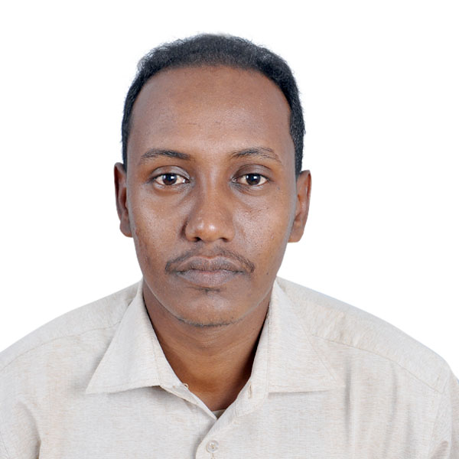

# Personal details:

* Name: Mustafa Adel Abuzaid Ali.
* Date of Birth: 30/9/1988.
* Place of Birth: Khartoum.
* Address: Sudan-Khartoum.

• Phone No: +249911405218, +249922037579.

* E-Mail [Address: mostafa.emarats@gmail.com](mailto:Address:%20mostafa.emarats@gmail.com)

# Qualification:

* EMIRATES COLLEGE OF SCIENCE AND TECHNOLOGY

Bachelor of information technology Grade: Excellent

* Master degree from Neelain University (2017)

# Experience:

* Design web site for shepeena investment Company

[www.](http://www/) Shpeena.com in 15/02/2015.

* Design web site for Rasan investment Company [www.](http://www/) Rasan-sd.com in 03/05/2015.
* Design web site for Alraid Services Office

[www.alraid-legal.com](http://www.alraid-legal.com/) in 01/06/2016.

* Design web site for Albir & Al-Tawasol organization

[www.](http://www/) bto-sd.org in 05/07/2016.

* Design web site for Gzaz investment Company [www.](http://www/) gzaz-sd.com in 15/08/2017.
* Design Islamic web site   
  [www.islamic-ways.org](http://www.islamic-ways.org) in 20/9/2017
* Teaching assistant in Emirates college of science and technology. from 01/04/2016 until now.

# Technical Skills & Knowledge:

* Application Software: MS office.
* Web design use:
  + Content Management Systems (Joomla & WordPress).
  + Laravel framework.
  + PHP & MySQL & CSS & html.
  + DREAMWEAVER.
  + Adobe Photoshop.

**Language:**

* Arabic : (Mother language)
* English : (Medium)

